CST2109 - Lab 7
Classification Algorithms
Student Name: Andrianna Wardill
Student Number: 041067235

The goal of this lab is to perform Classification on Titanic Dataset

Each question must be answered, and all the relevant screenshots must be included with your name (python code and Output).

Submit both the Word document and python file

Data Dictionary:

The dataset contains several parameters which were recorded about the passengers.

PassengerId: Passenger Identifier

Survived: (0 = No, 1 = Yes)

Pclass: - Passenger Class (1 = 1st, 2 = 2nd, 3 = 3rd)

Name - Name of the Passenger

Sex: Gender of the passenger

Age: Age in years

SibSp: The "SibSp" represents number of siblings and spouses the passenger had aboard the Titanic. It combines two categories:

Siblings: Brothers, sisters, stepbrothers, and stepsisters of the passenger.

Spouses: The passenger’s husband or wife (not including fiancés).

SibSp = 0: The passenger traveled alone or with no siblings or spouses onboard.

SibSp > 0: The passenger traveled with at least one sibling or spouse.

Parch: The "Parch" stands for "Parent or Children." It represents the number of parents or children that each passenger had aboard the Titanic.

* Parents refers to mother or father

* Children refers to sons, daughters, stepsons, or stepdaughters

The values in this column indicate:

0 = No parents or children aboard

1 = 1 parent or child aboard

2 = 2 parents or children aboard

Ticket: Ticket Number

Fare: Passenger Fare

Cabin: Cabin - 'U' is for Unkown

Embarked: Port of Embarkation (C = Cherbourg, Q = Queenstown, S = Southampton)

Lab Tasks:
- Perform EDA on the Titanic Dataset.

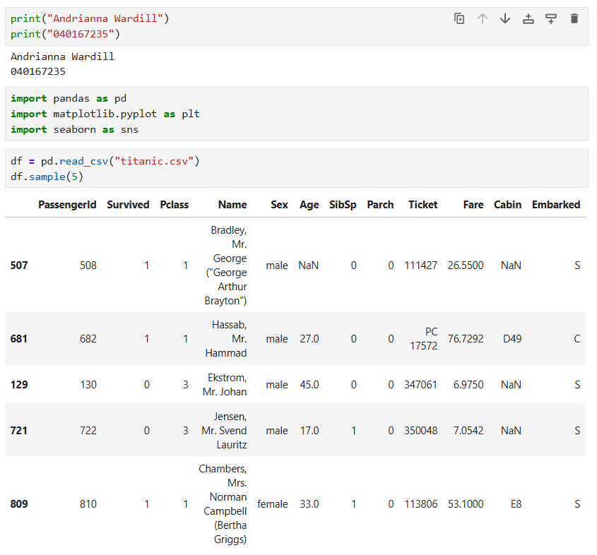
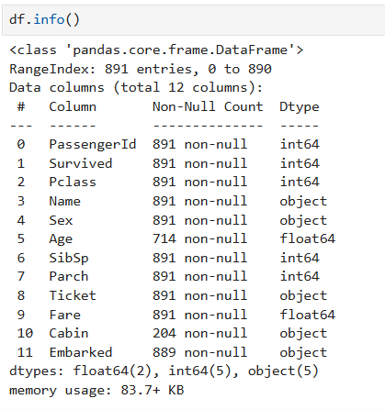
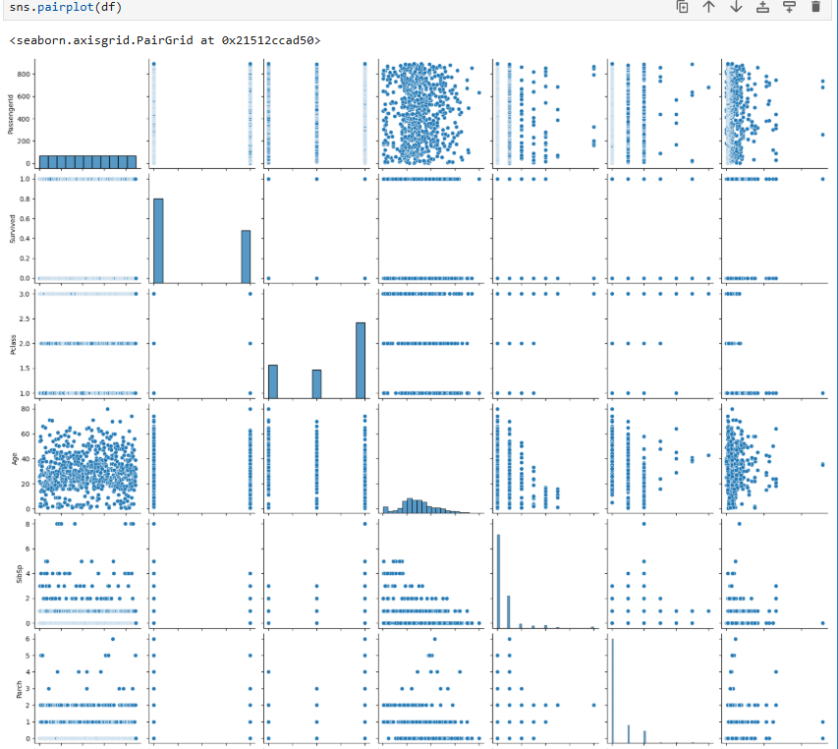
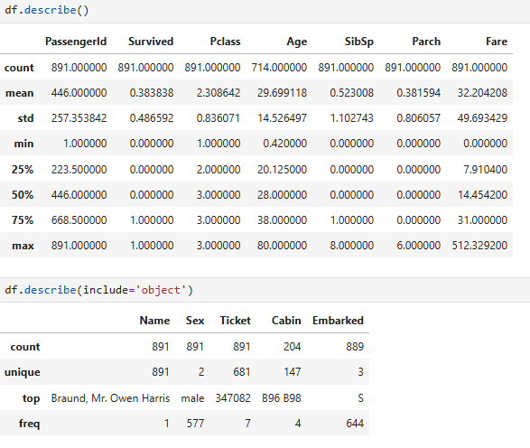
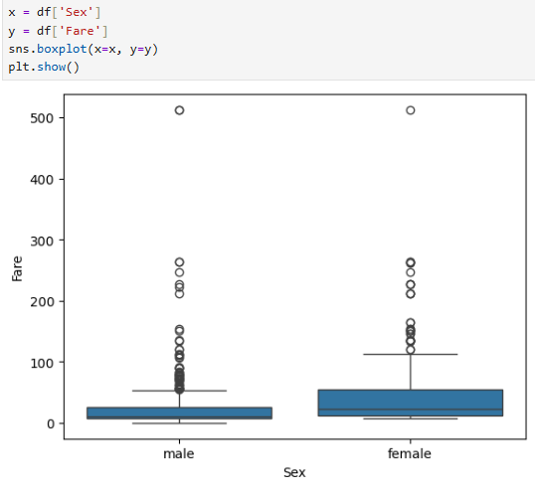
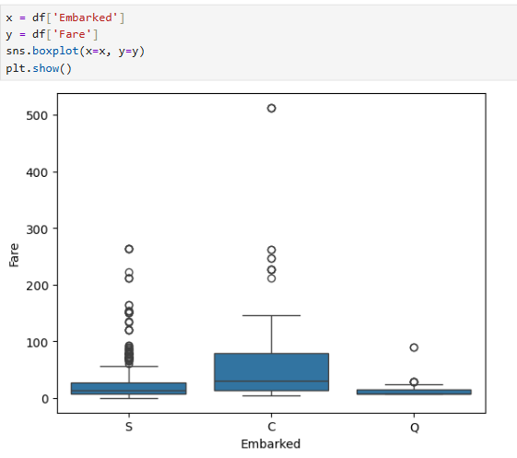
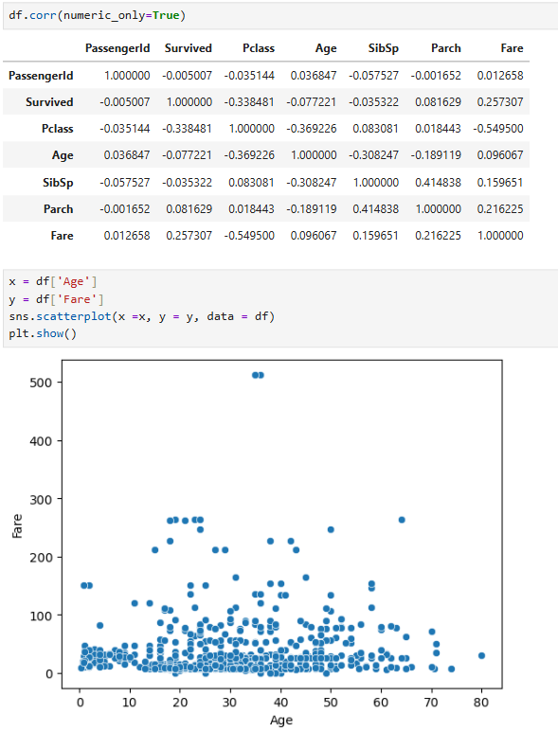
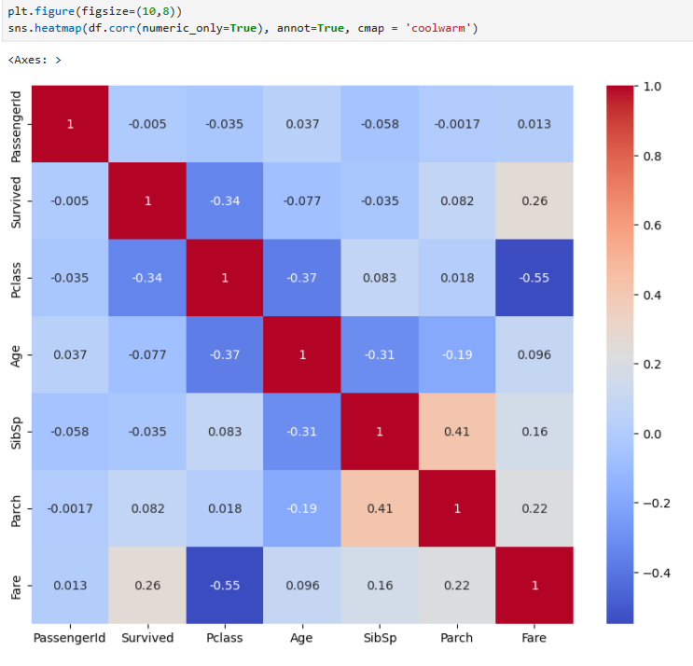

- Answer the following questions:
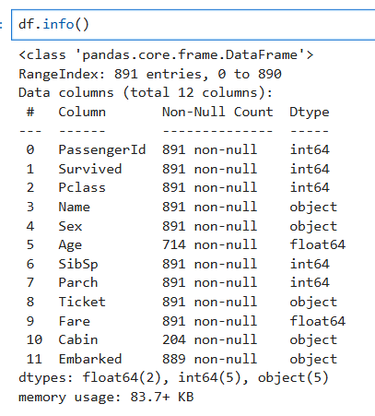
  - Number of instances? 891
  - Number of attributes? 12
  - How many missing values for each variable: Age – 177, Cabin - 687
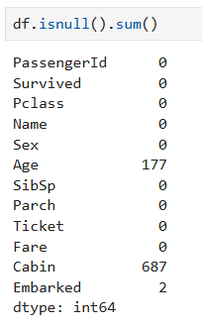
  - What is the target (Label) variable: The target variable is Survived.
- Perform Data Cleaning and Feature Engineering as needed.
- All columns should be numeric before applying Classification Algorithm. If you have any other types, convert them to the right type using pd.get_dummies()
  - Required conversions (add rows as required):
Column to be converted | Required Conversion/Preparation
PassengerId, Name, Ticket, Cabin | Dropped as not relevant for model
Age | Filled missing with median
Embarked | Filled missing using mode
Sex, Embarked | Used pd.get_dummies, converts both from object to bool
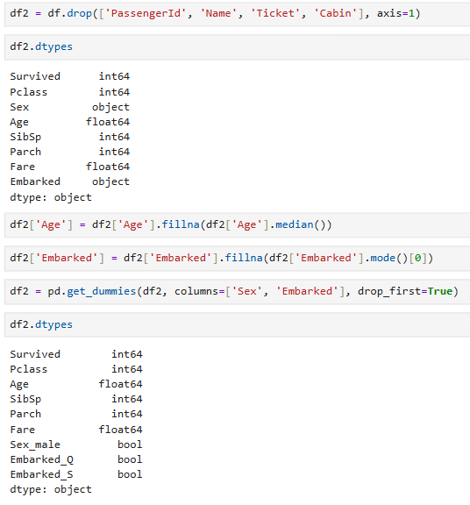
- Apply Logistic regression, Decision Tree, and Random Forest Classification models.
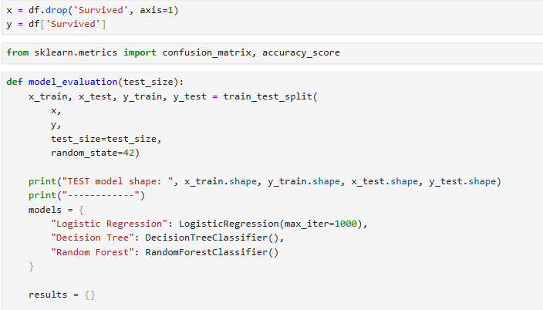
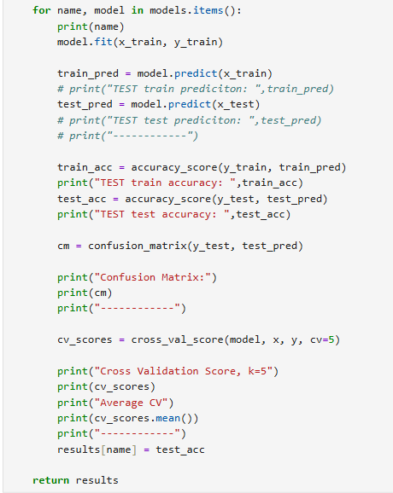
- Compute Confusion Matrix, Accuracy of each algorithm for the test set. Evaluate the performance of dataset with multiple Test / Train splits (80:20, 70:30, 85:15). Which one has the best performance.
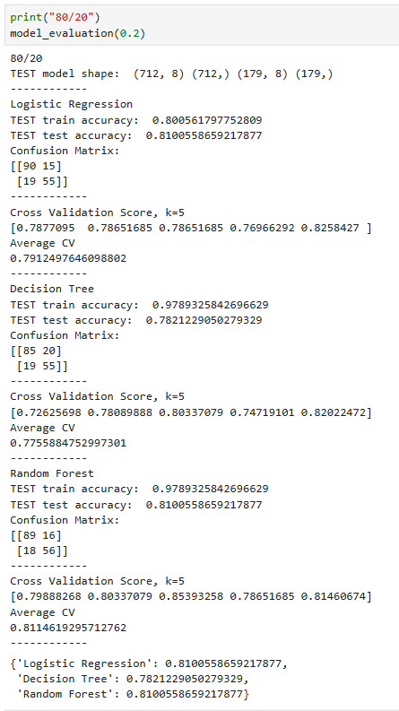
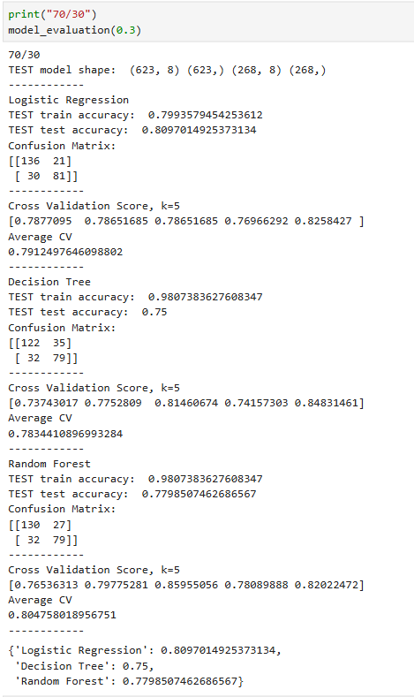
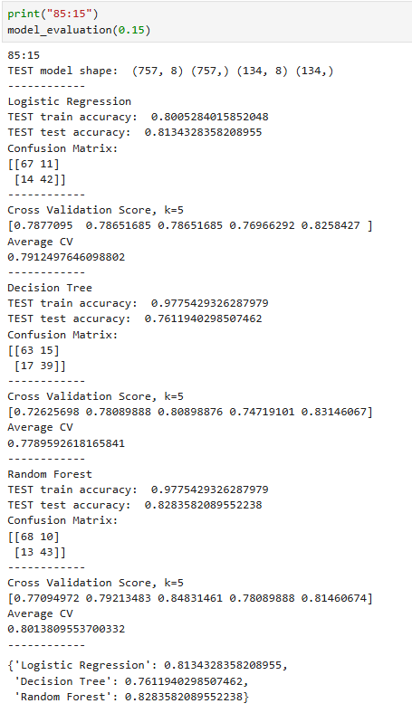

- Explain and tune Hyperparameters (n_estimators, max_depth, max_features)
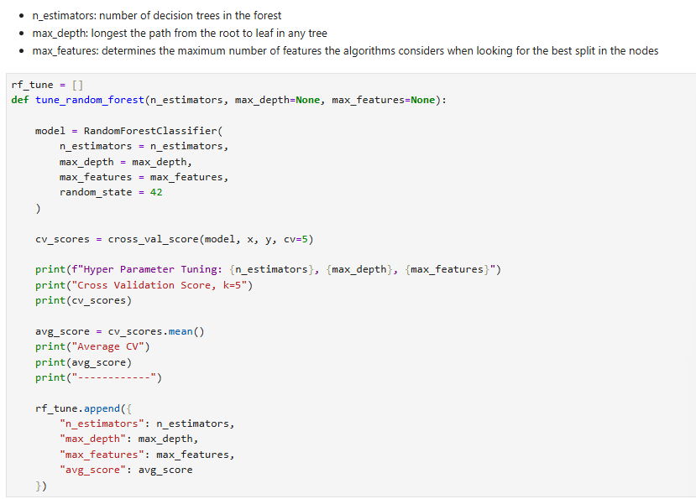
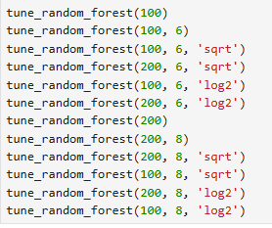
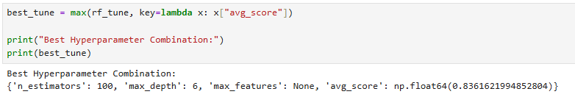
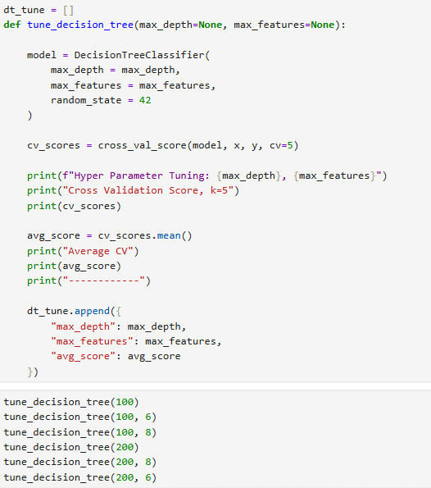
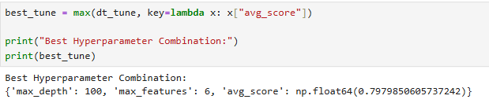
- Use cross validation to evaluate the model (kfold=5).
- Cross validation scores are available in question 5 screenshots of the model_evaluation function

